Come Celebrate Diwali at Walter Reed!

(the Hindu Festival of Lights)

An Indian lunch will be served for all attendees!
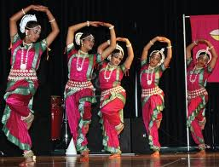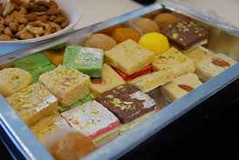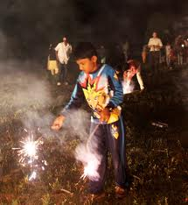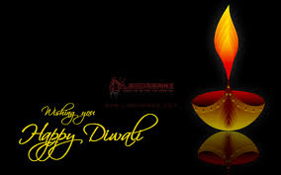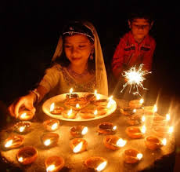EVENT: Diwali Celebrations
DATE: Friday 15th November 2013, TIME: 1200 to 1300 pm, LOCATION: Memorial Auditorium, WRNMMC, Bldg. 7, 3rd floor
8901, Wisconsin Avenue, Bethesda, MD 20889
POCs: Piragash.Swargaloganathan@health.mil, Sunil.Sudigala@health.mil,

Rashmi.Suman.civ@health.mil

